Four station balloon screen printing machine
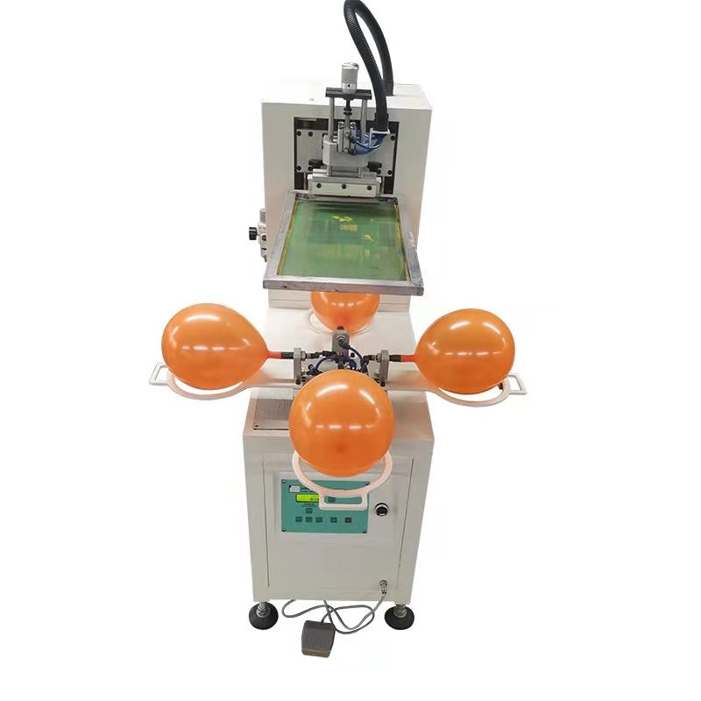

★Scope of application
Suitable for screen printing of all kinds of balloons

- Main parameters
Model | TX-QQ150 |  | Print color | monochrome
max printing area | 150*150mm |  | Printing speed pressure | 900-1200m/min
Mode of operation | semi-automatic |  | Inner diameter of balloon carrier | 150mm
Max screen frame size | 700*1000mm |  | Size of package carton | 1300*800*1300mm
Rated voltage/Power | 220V/1KW |  | Gross weight | 120(KG)

★Configuration instructions
① Microcomputer control each function, easy to operate, equipped with five automatic counter
② All pneumatic components adopt well-known brands, to ensure the machine quality
③ Front and rear oil scraping is driven by cylinder + linear bearing to ensure smooth and smooth movement
④ Screen lifting adopts cylinder + guide column drive.
⑤ The working table adopts the design of four stations, rotating one station every 90 degrees, automatic blowing, the size of balloon blowing can be adjusted.
⑥ Oil-free three-point combination does not produce exhaust oil mist pollution, suitable for use in dust-free rooms
⑦Can be customized according to customer requirements, to meet different requirements

★Product details
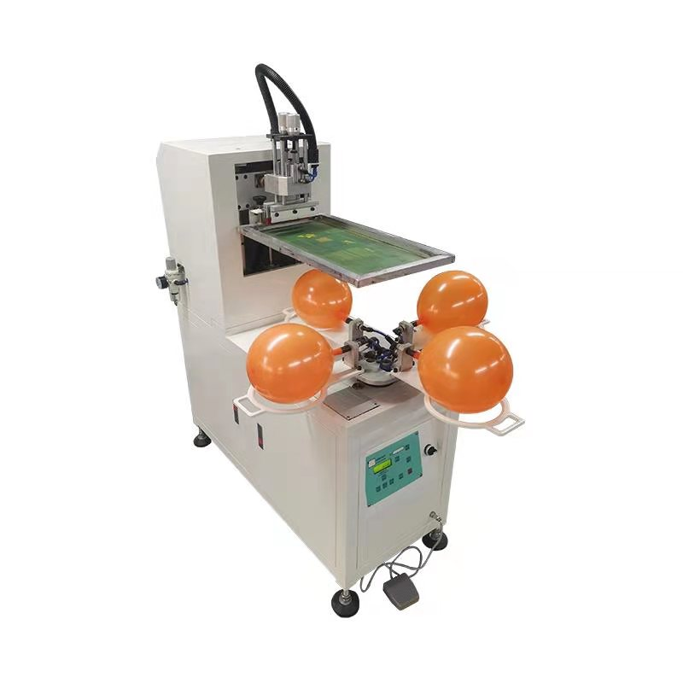

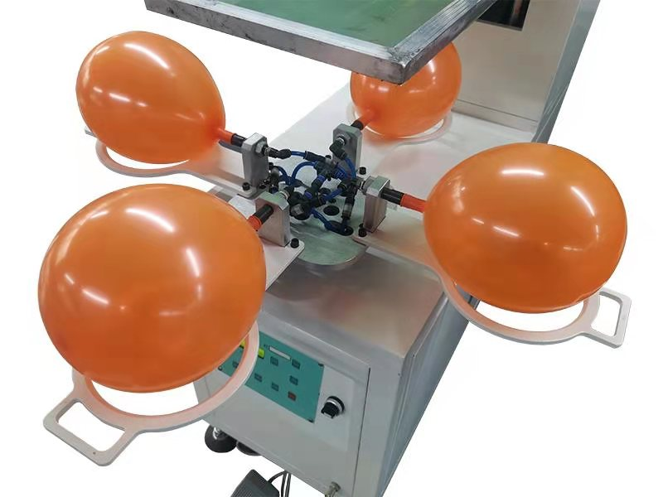
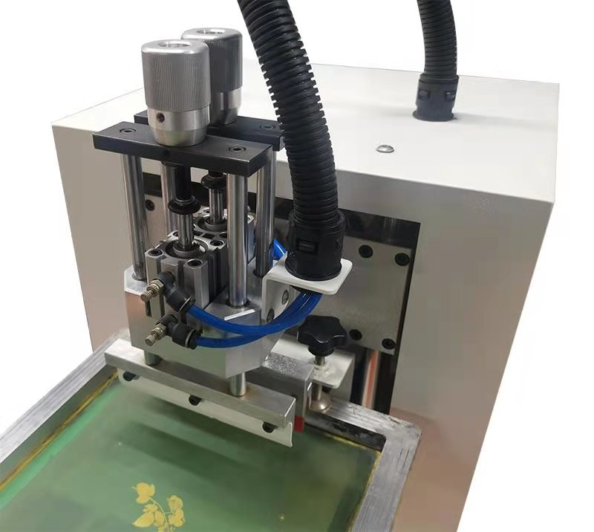
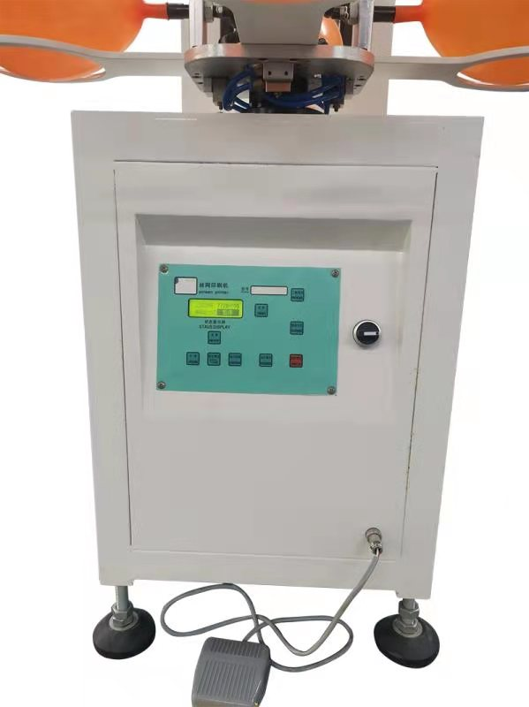

★Machine maintenance
① Before going to work to clean up the debris on the machine, the machine will be wiped clean. To guide rail, guide pillar, bearing and other moving parts to regularly add lubricating grease.
② Workpiece table is a key component affecting the printing quality, to prevent the impact of hard objects, printing, can not put the ink. God that water and other organic solvents dripping on the work surface.
③ The electric control panel and keys should be prevented from being damaged by direct or indirect contact with solvents such as water, boiling oil and water.
④ The frame paint is to keep the machine from rusting, to prevent direct or indirect contact with water, boiling oil and water and other solvents caused damage.
⑤ The sewage and dirt in the oil mist combiner should be discharged in time. To prevent it from being sent into the pneumatic components, which will affect the normal operation, clean the cup body regularly, and add PENG 2 lubricating oil into the oil cup of the oil mist combiner.
⑥ When adjusting the limit valve, it is necessary to loosen the forcing nut before adjusting it by hand. The handle screws on the machine are used for positioning. After firm positioning, there is no need to tighten them.
⑦ After work, turn off the power/air supply, clean the screen and keep it safe. Resistant to dust/pressure/hard objects piercing.

★Distribution list
No | Tool name | Spe | Unit | Qty | Note
1 | Power line | standard | PC | 1
2 | Foot switch | standard | PC | 1
3 | Cross screwdriver | standard | PC | 1
4 | monkey spanner | standard | PC | 1
5 | Hex Wrench | standard | PC | 1
6 | work-box | standard | PC | 1
7 | Operating instruction |  | PC | 1
★Enterprise image
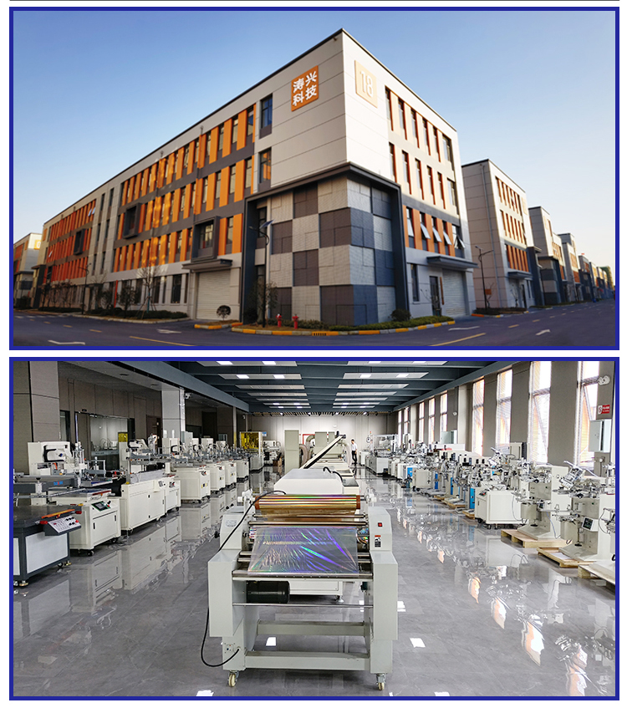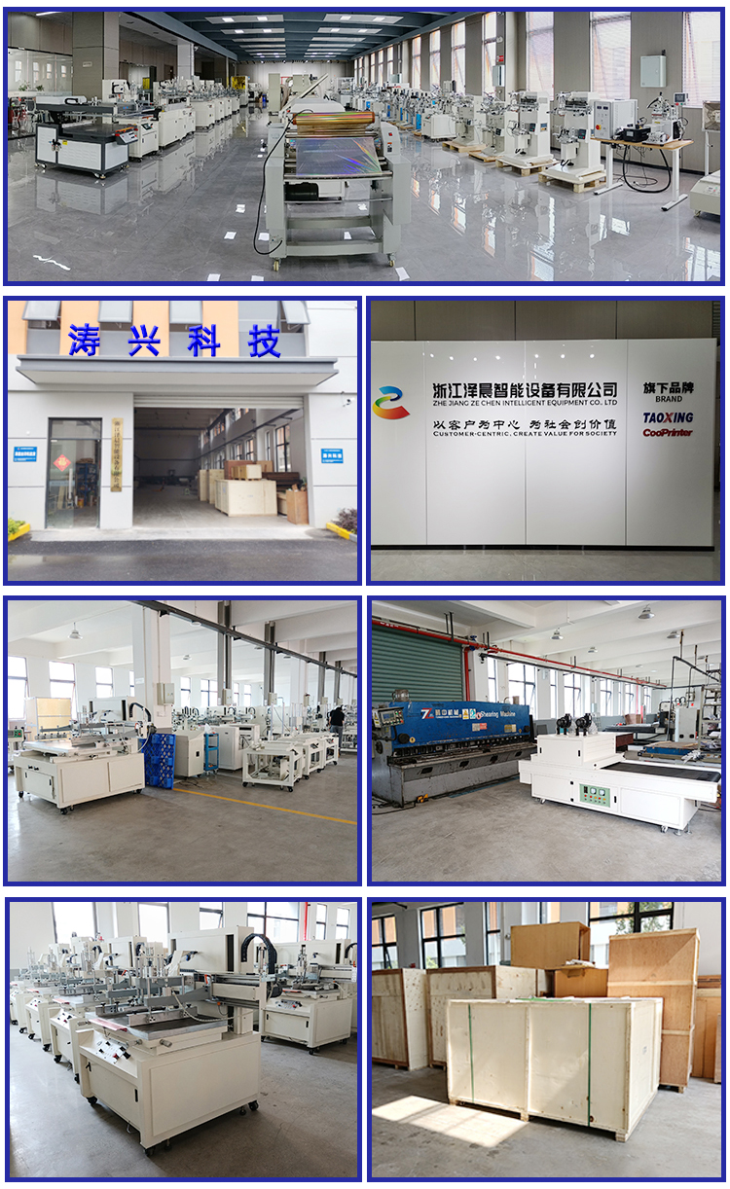
- Company honor
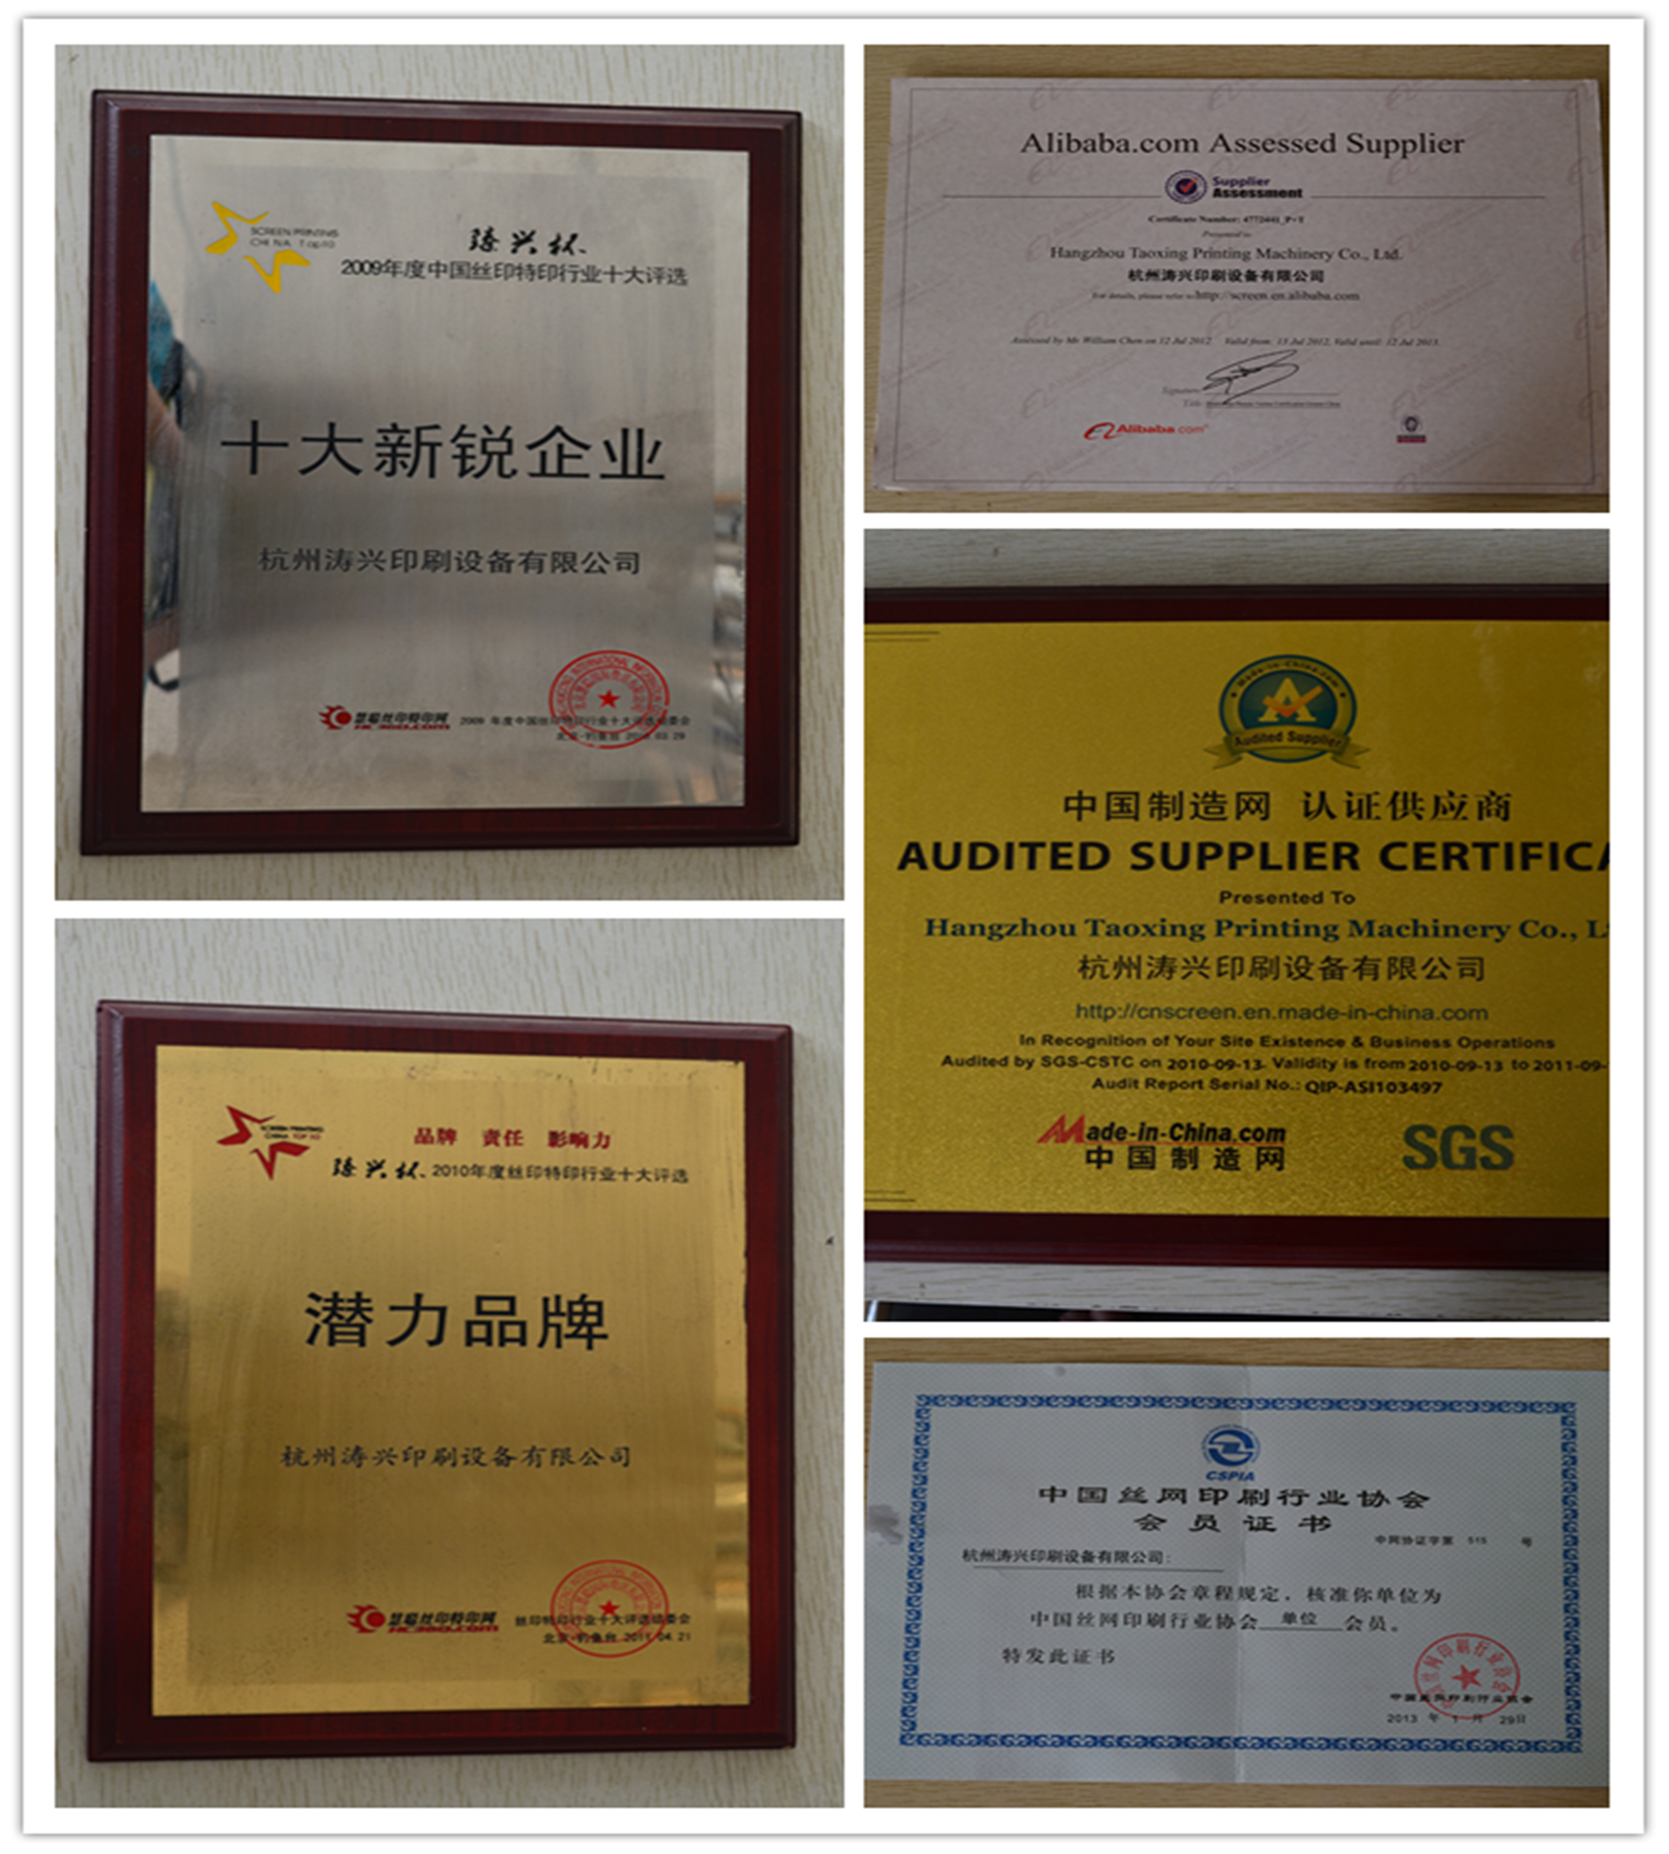

- After-sales service description
- All factory products, we can provide installation, debugging, technical training.
- After installation and debugging, free warranty for one year (except for wearing parts and man-made damage), lifetime maintenance.
- Irregularly visit maintenance, on-site operation, technical training.
- After sales contact: 0571-86927248 15268806328 Mr. Wen.
- After-sales service content：
  - If there is a malfunction of the equipment, we will communicate by phone first. If the problem cannot be solved, we will arrive at the scene to solve the problem as soon as possible.
  - After-sales service not only includes equipment maintenance, but also includes the dedicated support of process technology. Our technical staff can carry out on-site technical training, and provide a full set of screen printing process technology, information and equipment solutions.
  - There are professional and technical personnel to visit and track the use of user equipment from time to time.
  - Screen printing equipment and auxiliary equipment repair, maintenance, etc.
Design and customize special product screen printing equipment and auxiliary equipment.

